Compass Business Process Overview Document

Table of Contents

Revision History 1

High Level Process Definition: 2

Business Impact: Medium 2

Application Hierarchy: 2

Compass Application 2

Process Flow Compass & EPS 3

Process Flow PSA 4

Business Scenarios: 6

# Revision History

|  |  |  |  |
| --- | --- | --- | --- |
| Version | Revision Action | Person(s) | Date |
| 1.0 | Initial Draft | Shiva Kumar Salve | 06/11/2019 |
| 1.1 | Review with Offshore | Vishnu Kambhampati |  |
| 1.2 | Final Signoff/Approval |  |  |

# High Level Process Definition

Compass is a process which involves Dispensing, Order Creation, MDS/CDS Management, Patient Maintenance, Stock Maintenance and Store Reports.

# 

# Business Impact: Medium

As Compass is Patient Prescription Dispensing Process. Medium level impactful on business.

# 

# Application Hierarchy

Below are the list of applications used to perform Compass Process.

Followed by the process flow.

# Compass Process involves following Applications

* Compass
* PSA (Professional Services Applications)
* Daemon Services
* Responsible Pharmacist

**PSA (Professional Service Application)**

* Electronic Prescription issue and claims
* User Maintenance

**Daemon Application**

* Stores received messages in database
* Reads messages to send from database

# Process Flow - EPS Changes

Schedule 2 & 3 CD items [Compass]:- The ability to display and print both words and figures for CD schedule 2 &3 items. This will be required by NHS Digital if the system is continuing

This is a change in the Compass. For CD drugs, the amount must be displayed in words in the Rx, Prescription Summary screens. Also in any other screen where the amount is currently being shown. The amount in words is read from the electronic message.

# Process Flow

**PSA (Professional Services Application)**

* Carry out NHS services.
* Electronic Prescription issue and claims
* User Maintenance

# Process Flow

**Compass Available Prescription Menus**

* Dispensing
* Order creation
* MDS/CDS management
* Patient maintenance
* Stock management
* Store reports

# Process Flow

**Non Electronic Dispensing (Non MDS/CDS)**

# Process Flow

**Electronic Dispensing (Non MDS/CDS)**

# Business Scenarios - Manual:

## **Create Patient**

The tester selects ‘Patient’ from the ‘Maintenance’ option on the menu bar.

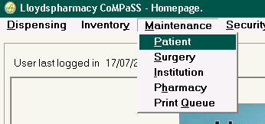

A search for patient; Peter Potato show ‘No matches are found’ (screen bottom left) and the ‘Create’ button is enabled.

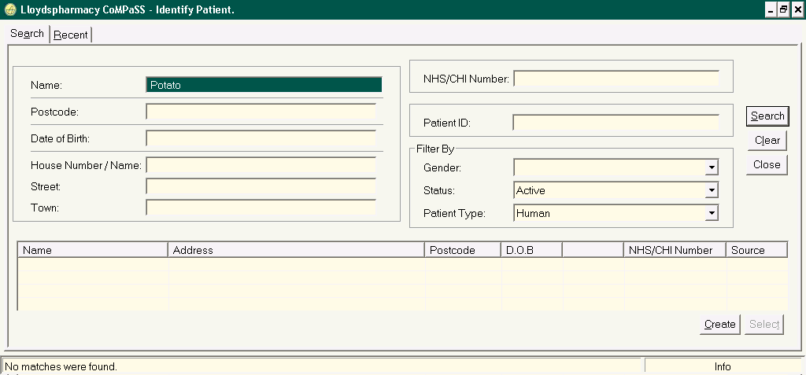

Updating new Patient details.

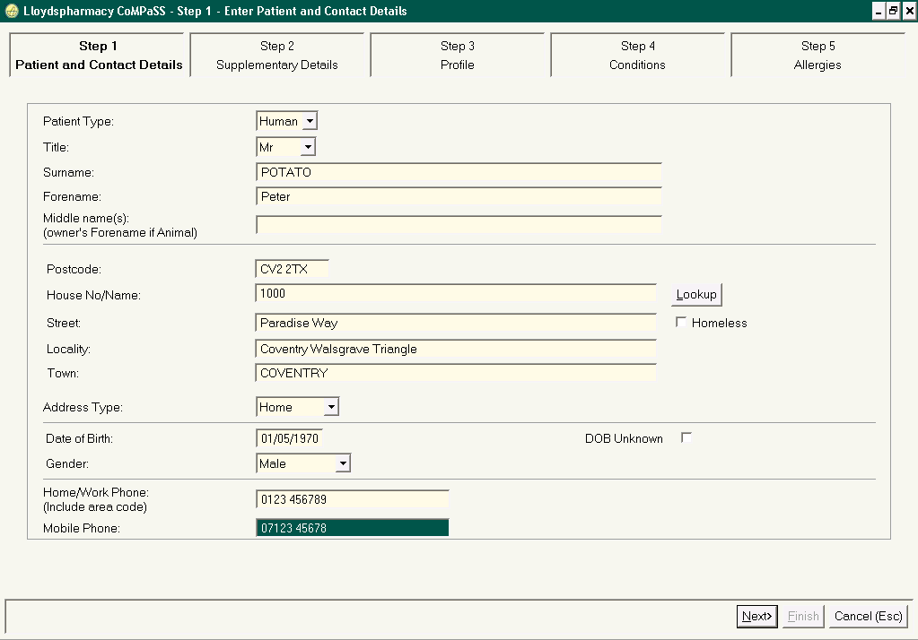

Surgery Details updated.

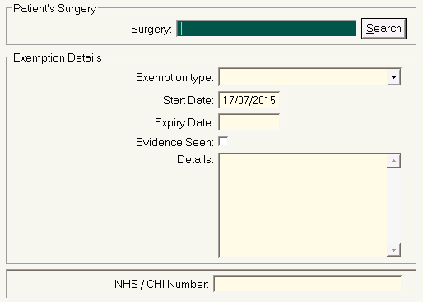

Successfully created new Patient.

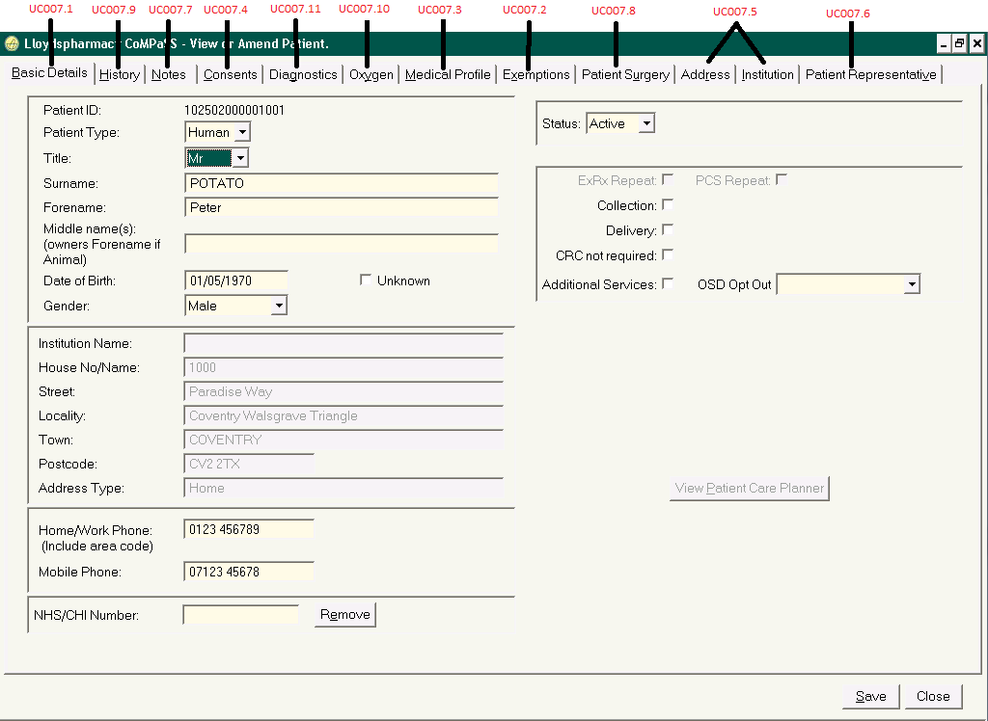

# Non Electronic Dispensing (Non MDS/CDS)

Tester selects Dispense Rx’ from the ‘Dispensing’ menu option in Compass.

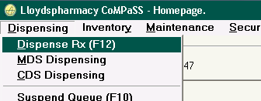

The ‘Receive Prescriptions’ screen is displayed, with the tabs.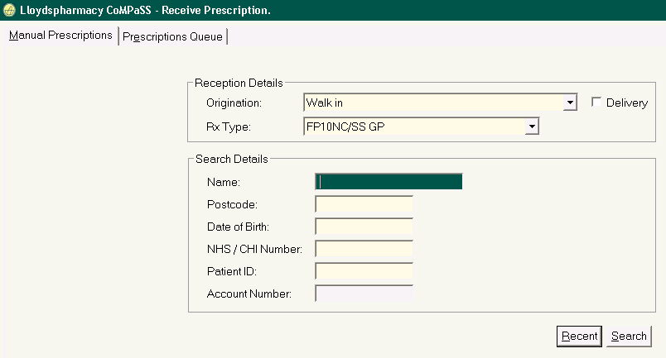

Tester selects the ‘Manual Prescriptions’ tab

The user should specify the follow:

* Origination type from the options; Walk in, Walk in – call back, Express Repeat Prescriptions or PCS.  
  The option selected is important, if OSD is in use, as it drives selection/non-selection of the OSD flag.
* Prescription type  
  The values listed represent form types/ transaction types.
* Search detail criteria

The Prescription Entry screen is displayed with the selected patient details

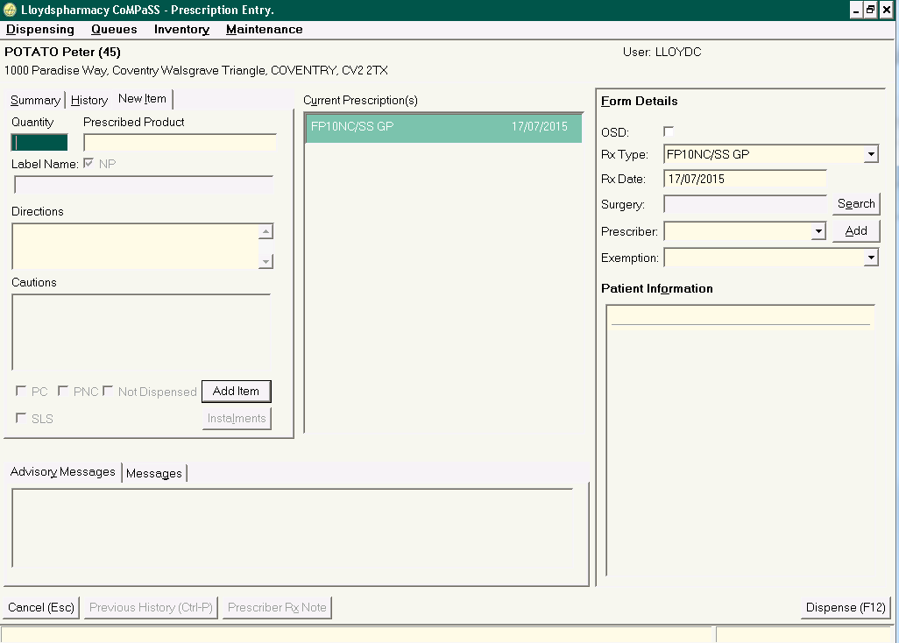

**Select New Item Tab**

The “New item” tab is selected. Update Quantity, Prescribed Product and Directions details.

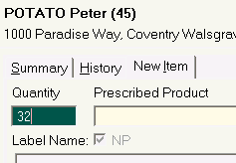

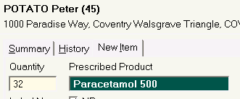

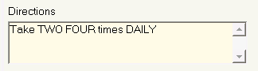

‘Add item’ button is clicked in ‘Current Prescriptions’

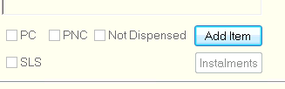

Form details updated

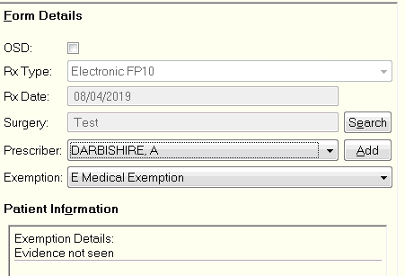

Tester clicks “Dispense (F12)” to progress the dispense Prescription.

Tester clicks “Continue (F12)” to progress the dispense Prescription.

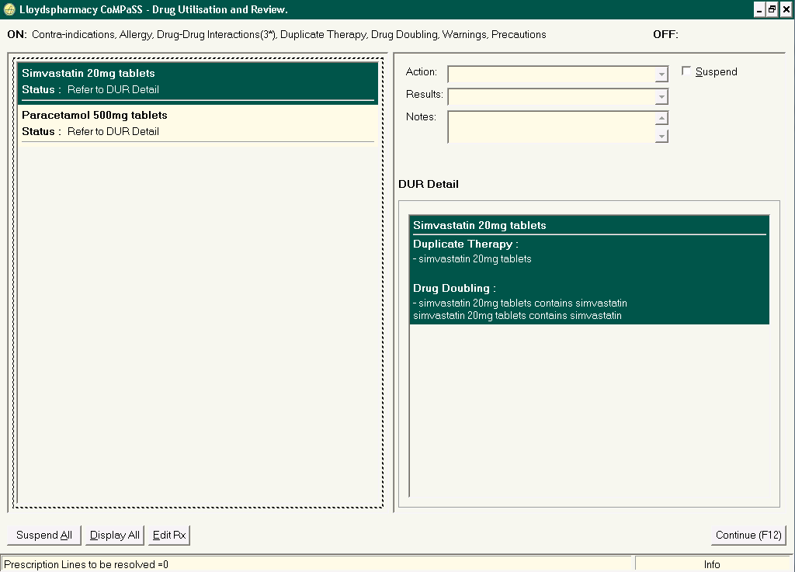

Tester clicks “Dispense (F12)” to progress the dispense Prescription.

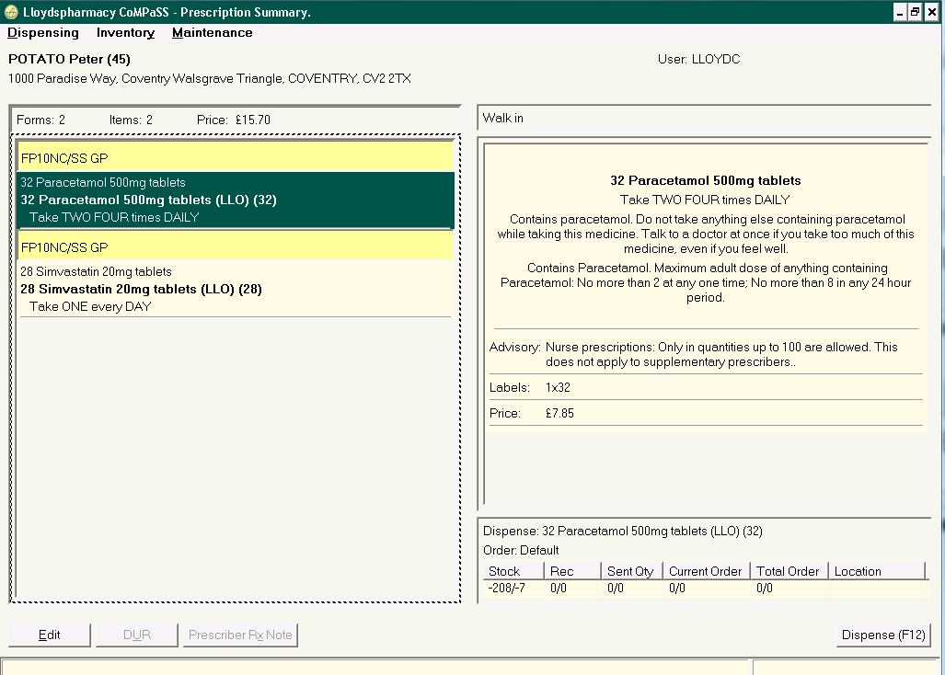

If there is insufficient stock for a prescribed line, at the point of assembly, then the user can select to create an owing.

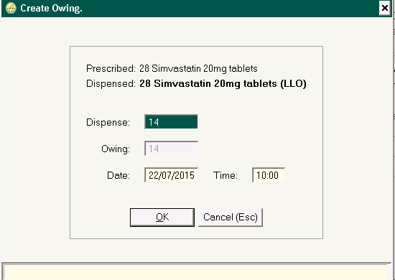

After updating Owings details “Print Endorsements” screen will appear for each prescription form in the ‘Current Prescription’ transaction. Tester clicks on Print(F12) and update the additional information details.

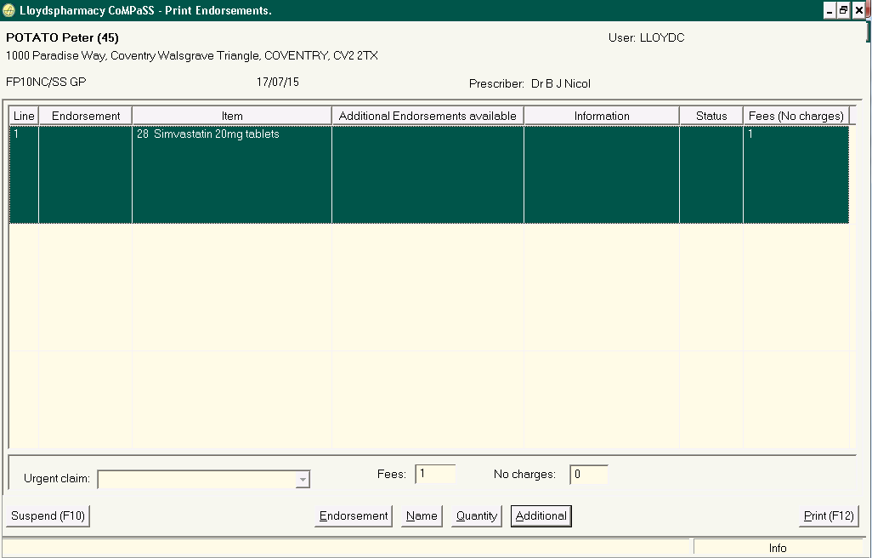

## **Electronic Dispensing (Non MDS/CDS)**

In England, GPs generate electronic prescriptions of type EPS1 or EPS2 and upload them to the NHS ‘Spine’.

**Manage Electronic Prescriptions**

In PSA, the tester selects “Electronic Prescriptions” from the ‘Dispensing Services’ menu bar option.

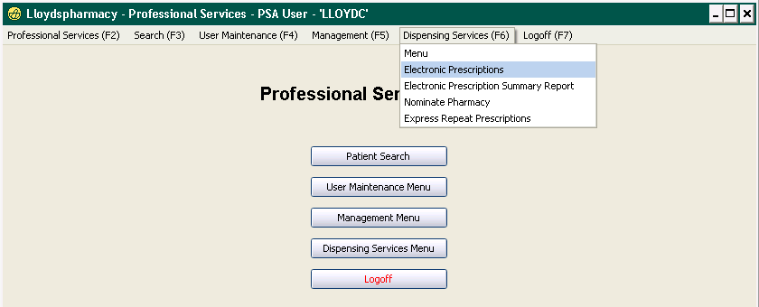

The Live Escripts screen is displayed.

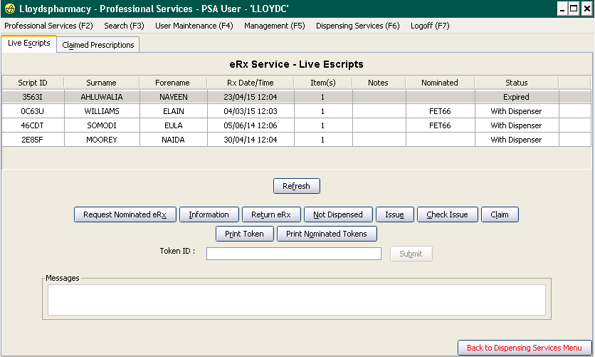

**Statuses displayed:**

* Prescription Requested Prescription scanned/ token number submitted and prescription request messsage sent to NHS
* Prescription Request Rejected Prescription request message rejected by NHS (rare)
* With Dispenser Prescription response message (e-script) received and displayed in CoMPaSS Prescription Queue
* Returned E-script returned to spine (England), status updated and transaction undone (if applicable)
* Return Rejected Return request was rejected by NHS (England – rare)
* Fully Issued Prescription items handed to customer, but prescription transaction suspended at endorsing
* Issue Rejected Issue step rejected (rare)
* Witheld If all lines have been flagged Not Dispensed
* Expired Predcription has date expired
* Ready to Claim Claim has been sent (as a result of issue), but success ack has not yet been received
* Claimed Successfully claimed (success acks have been received)
* Claim Rejected Claim rejected by NHS
* Claim Cancel Pending User has selected to cancel claim, but success ack not yet received
* Claim Cancel Rejected Claim cancellation rejected by the NHS (rare)
* Claim Cancelled Claim has been successfully cancelled
* Ready to Issue Prescription has been dispensed and is awaiting collection/deliver (issue) to patient
* In CoMPaSS Part Issued Part issued to patient, but balance yet to be dispensed (owing or instalment)
* Ready to Isse Part Part supply dispensed and ready to issue (instalment or owing)
* Error message validation error e.g. bad ack

The tester select the respective token number and then clicks the “Information” tab to view the electronic prescription information. The “Prescription Information” screen is displayed.

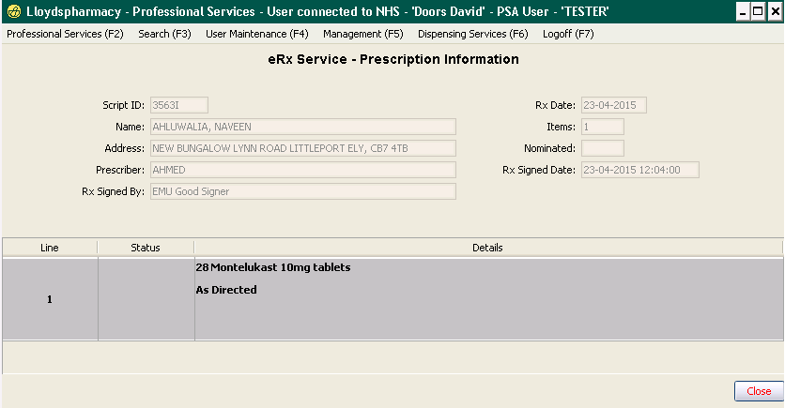

When a prescription status changes to “With Dispenser”in PSA, the same form is received and displayed in CoMPaSS on the Prescription Queue.

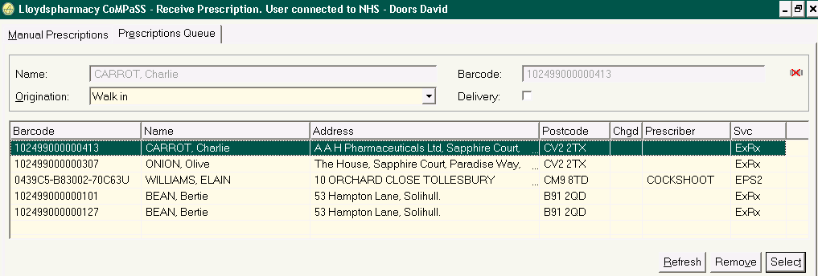

To initiate dispensing, the tester highlights the recently received prescription on the Prescription Queue and then selects “Select” button.

The application matches the electronic prescription to a patient record in CoMPaSS/PSA by matching the NHS number then the “Prescription Entry” screen is displayed pre-populated with data from the electronic message.

The e-script is processed in the same way as a non-electronic prescription dispensed.

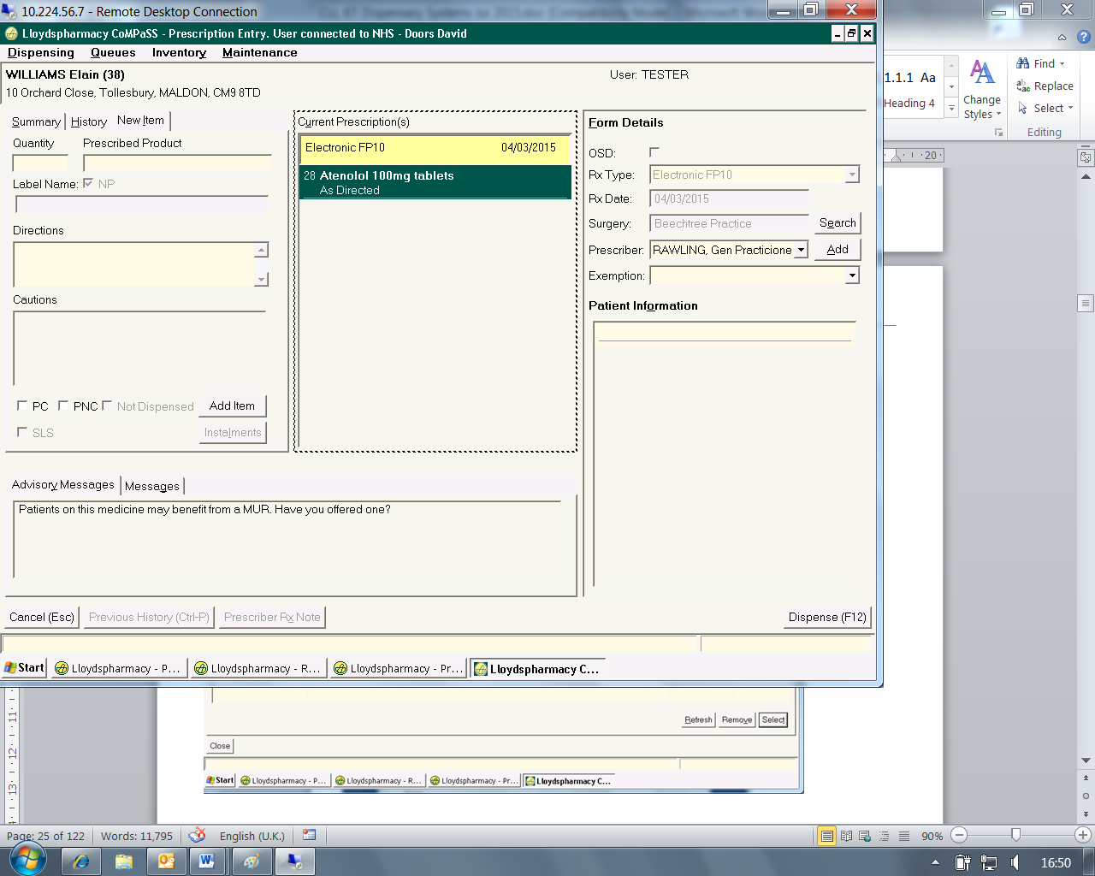

After successful dispense of the prescription, the status of the prescription form is then updated on LiveEscripts as “Ready to issue”.

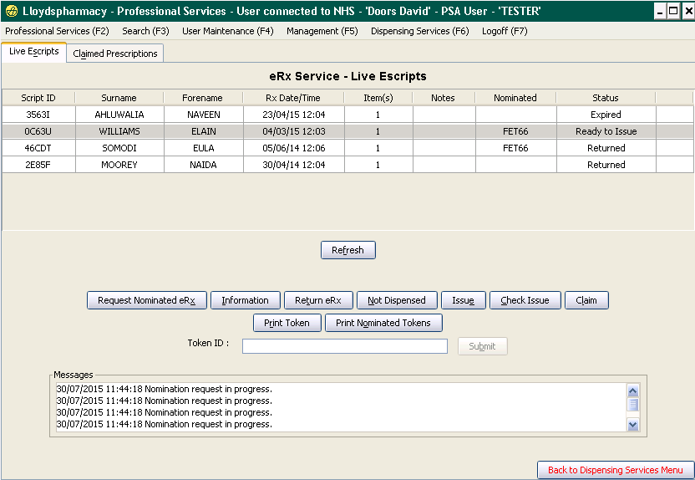

When the Prescription is collected by/ delivered to the patient, the tester clicks “Issue” in the Live Escripts screen. The system then compiles and sends the appropriate electronic claim message to the NHS, dependent of prescription type.

CoMPaSS compiles and sends two messages in respect of an issued prescription:

* Dispense Notification (conveys information about what has been dispensed)
* Dispense Claim Information (conveys information to support reimbursement)

These messages and associated acknowledgement messages may be viewed via the daemon. Upon receipt of successful acknowledgement messages, the status of the prescription updates to ‘Claimed’. The Prescription is viewed on the “Claimed Prescriptions” tab.



1. **OSD_dispense a CDS manual Rx**

“Off Site Dispensing” (OSD) factory is used to assemble and label medicine/ devices on behalf of pharmacies, where the patient is on a repeat collection service or CDS/eMAR service, thus allowing time for the prescriptions to be assembled offsite and distributed back to the pharmacy in time for ‘collection by’/ ‘delivery to’ the patient

Patient prescription transactions may be flagged for OSD, as seen by the user on the ‘Prescription Entry’ screen.

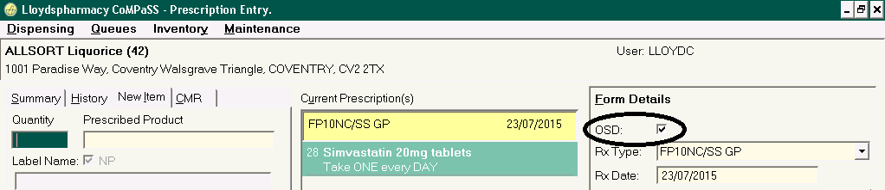

The following exceptions also apply:

* Individual patients may be flagged to ‘Opt Out’ of OSD, in which case the OSD box will be disabled (and defaulted to unchecked).
* Institutions may be flagged to ‘Opt Out’ of OSD, in which case the OSD box will be disabled (and defaulted to unchecked).
* If the dispensing is a result of ‘Undo & Re-dispense’ then the OSD box will be disabled (and defaulted to unchecked) in all cases.
* If the dispensing is non MDS/CDS, but for an MDS/CDS patient, then the OSD check box will be disabled (unchecked)
* If the prescription in context has an existing OSD status (i.e. it is an OSD script being dispensed locally) then the OSD flag will be unchecked and disabled.
* If the dispensing is MDS/CDS and the patient CMR for the cycle in context contains one or more lines flagged ‘Do not send data’ (implies complex dose) then the OSD flag will be unchecked and disabled.

Dispense process is followed.

OSD data entry is performed as one business process by one tester and then accuracy and clinical check is performed by another tester.

### **Accuracy & Clinical Check**

The tester selects ‘Accuracy and Clinical Check’ from the OSD option on the menu bar.

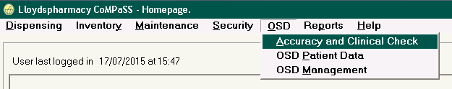

The ‘OSD Data Accuracy and Clinical Check’ queue is displayed. Each entry on the queue represents a Patient Prescription (Rx) i.e. the forms processed in one transaction (can be one or many forms).

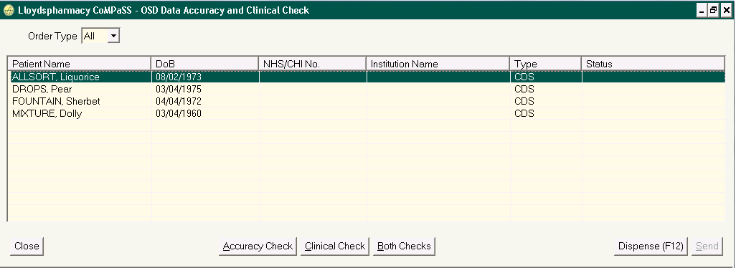

If the tester is a Pharmacist, then they can select to perform either “Accuracy Check”, “Clinical Check” or “Both Checks”. If the tester is an Accredited Dispensing Technician (ACT), then they can only select to perform an ‘Accuracy Check’. Either tester can select to “Dispense” the Rx locally if required e.g. the patient calls in early asking for their medicines.

If the tester selects to perform ‘Accuracy Check’, then the ‘Data Accuracy Check’ screen is displayed

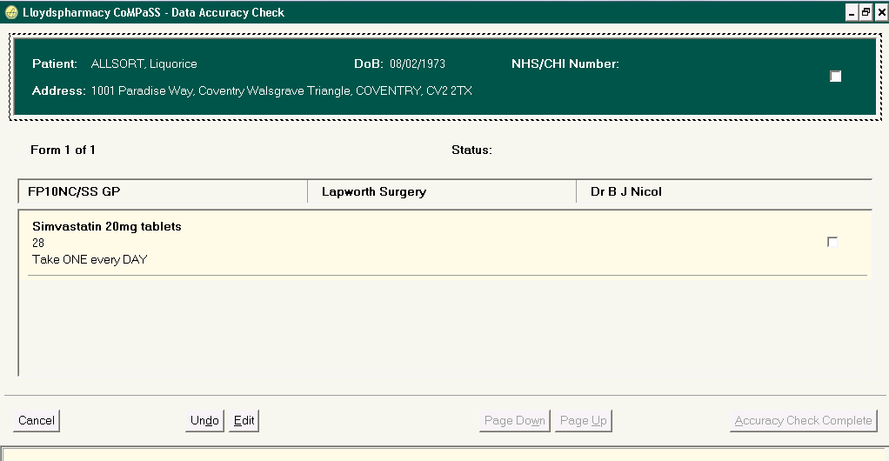

The tester checks the detail (checking that the data from the prescription has been correctly transcribed into CoMPaSS) and indicates successful checks by ticking the check boxes for patient data and form lines data (a check box for each line).

From the “Accuracy Check” screen, the user can select to undo data entry or edit the data entry, if necessary. If both forms and lines have been flagged as successfully checked, then the tester selects the “Accuracy Check Complete” button to confirm the check is complete. The patient Rx status on the queue is updated to “Accuracy Checked”.

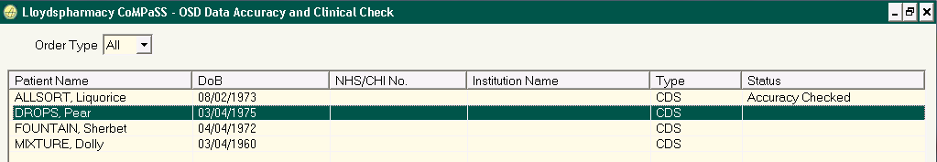

If the user selects to perform “Clinical Check”, then the “Clinical Check” screen is displayed.

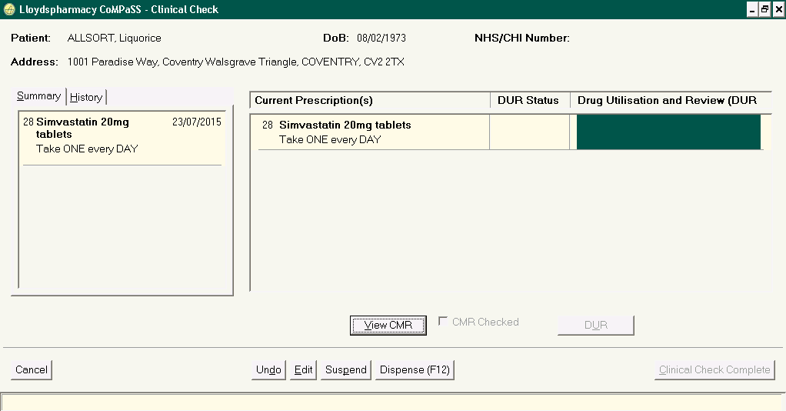

If any DUR is applicable, then this is indicated in the DUR columns and the tester selects “DUR” to view the full detail.

If the transaction is a CDS transaction, then the user must select to “View CMR” to check that the CMR has been set up correctly, as CMR data in respect of dosing quantities and administration times is sent to the factory to inform tray assembly.

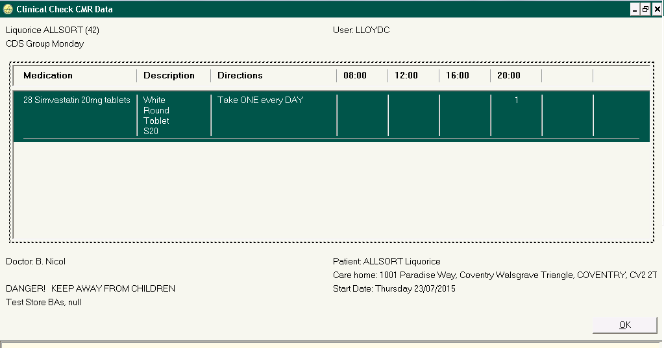

When the CMR has been viewed, then the “CMR Checked” tick box is enabled, so that the tester can confirm this check has been completed.

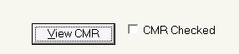

The tester can choose to undo or edit the data entry from the Clinical Check screen (as they could from the Accuracy Check screen), but they also have two further buttons for optional use:

* “Dispense (F12)” – to dispense the prescription locally, if required
* “Suspend” – to suspend the prescription at clinical check if they wish to consult with the prescriber about an aspect. Suspended prescriptions can be subsequently resumed from the suspend queue.

If the check is successful (i.e. that the prescribed lines are clinically suitable, as prescribed, for the patient), the tester selects the “Clinical Check Complete” button. If the Patient Rx has only been clinically checked, then the status updates to ‘Clinically Checked’, but if both checks have been completed, then the status updates to ‘Complete’.

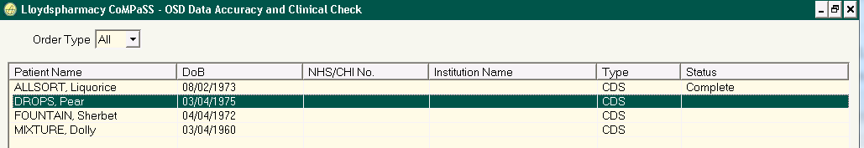

Statuses on the Accuracy and Clinical Check screen may be:

* Blank (unchecked)
* Accuracy Checked
* Clinically Checked
* Suspended
* Complete (both checks completed)